INSTALLATION EXERCISES

EXERCISE 3 → Create a 64bit machine and install Ubuntu with the configurations asked

As in the previous exercise, before starting, in order to have a more complete experience (and for later exercises), it is highly recommended to install the VirtualBox extension pack. You can download it from the official VirtualBox webpage or make a direct download with this link: https://download.virtualbox.org/virtualbox/6.1.16/Oracle_VM_VirtualBox_Extension_Pack-6.1.16.vbox-extpack. This will let us have some more functions such as 3.0 USB support.
This is the process of importation:
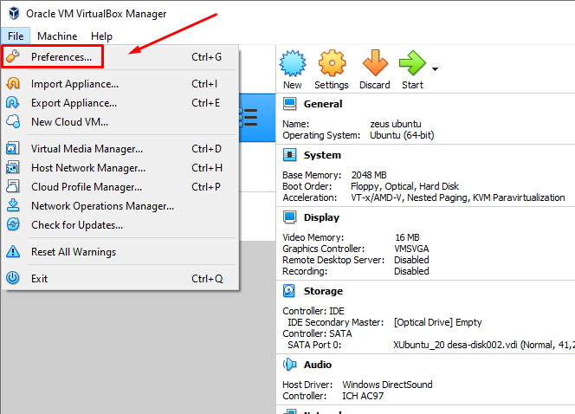

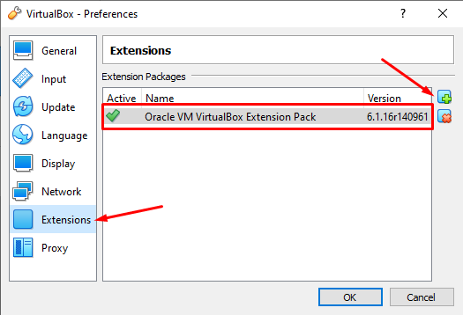

CREATION OF OUR VIRTUAL MACHINE:
The first thing we need to do is to create our new virtual machine. This time we need to select the Ubuntu 64bit version and the Linux type.

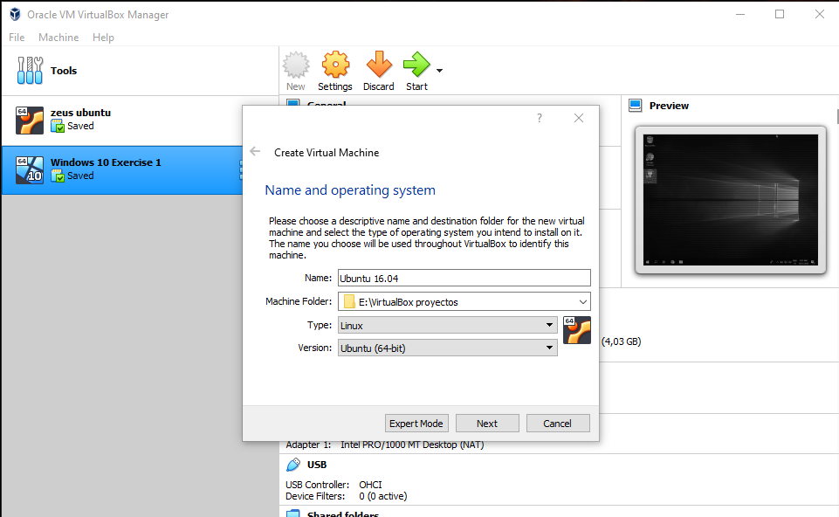

Then we need to set a memory for our virtual machine. This time we will have a 2GB (2048MB) RAM memory and only one hard drive (of 30GB). The process for this hard drive is the same as in the previous exercise: we need to set it at the time and set it as “Dynamically allocated” for a better usage of our physical computer’s memory.
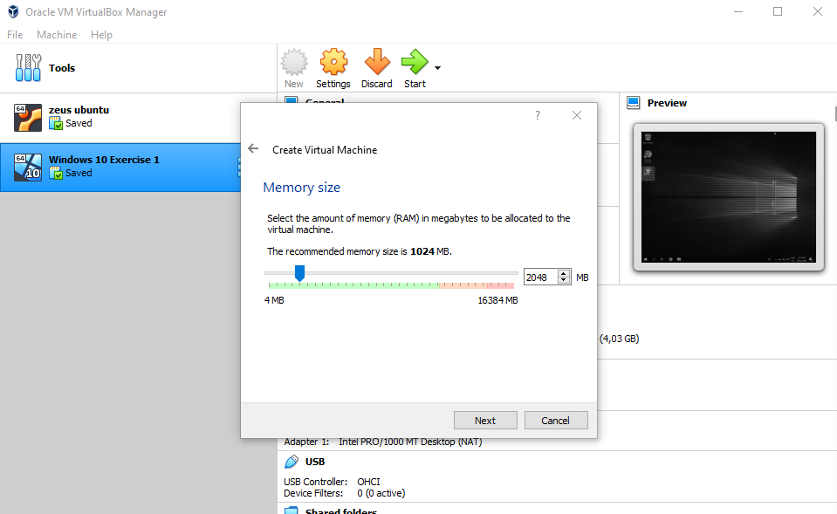
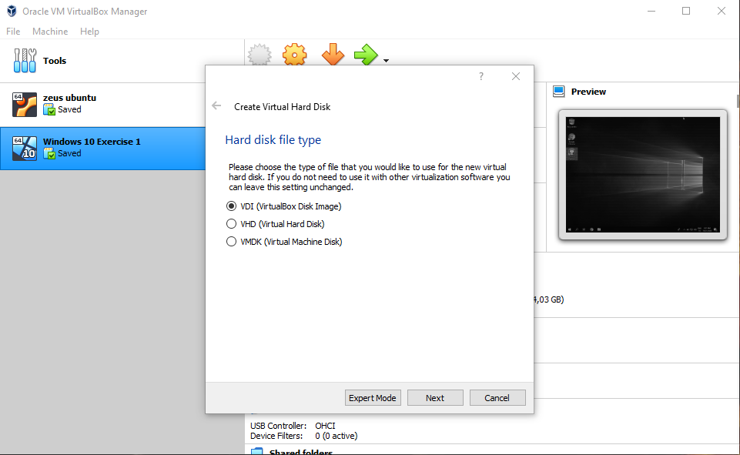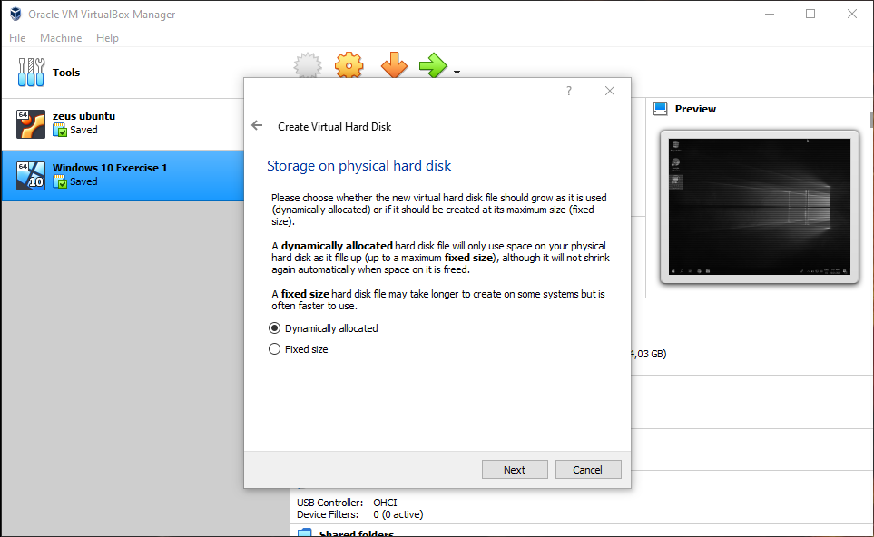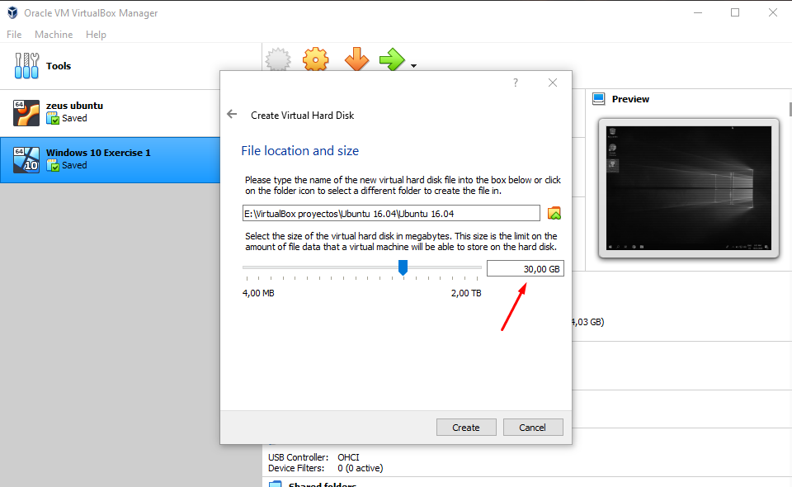

After finishing this first process, we need to adjust the final settings for our virtual machine.

We need to go to “General”, “Advanced” and change both options to Bidirectional. This will let us interact with the physical computer when using the virtual machine.
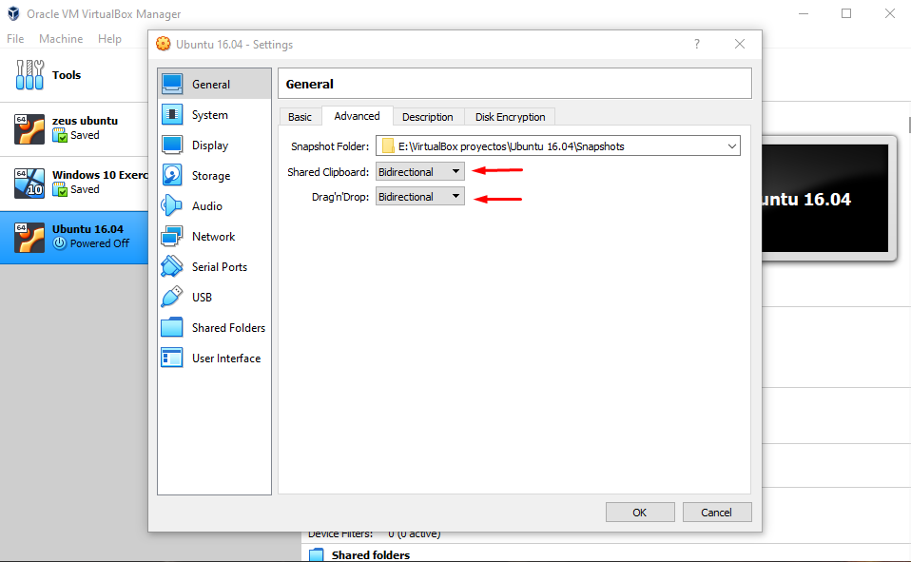

Then we need to go to “Shared Folder” and create a new one. We have to set the file location (but this time, it must be in our external disk), name and tick “Auto-mount” (VERY IMPORTANT).
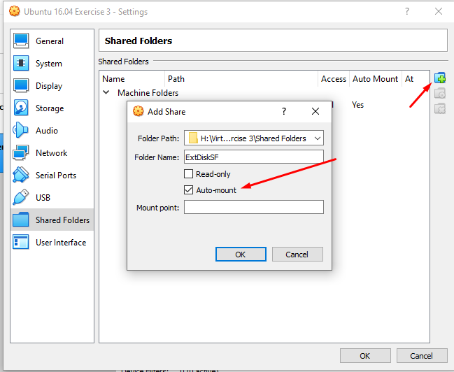

Finally, we need to go to “Network” and change the “NAT” option to “Bridged Adapter”, as we did in the previous exercise.
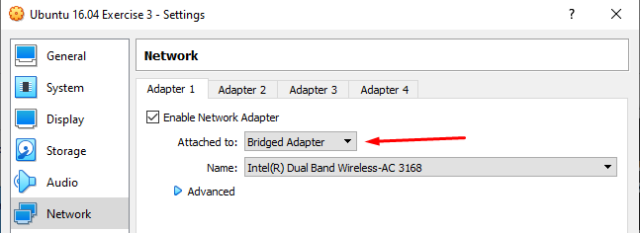

UBUNTU INSTALLATION:
Now we will go to “Storage”, click the empty CD, go to the pointed out icon to select the ISO file we want to use, click “OK” and start the virtual machine.

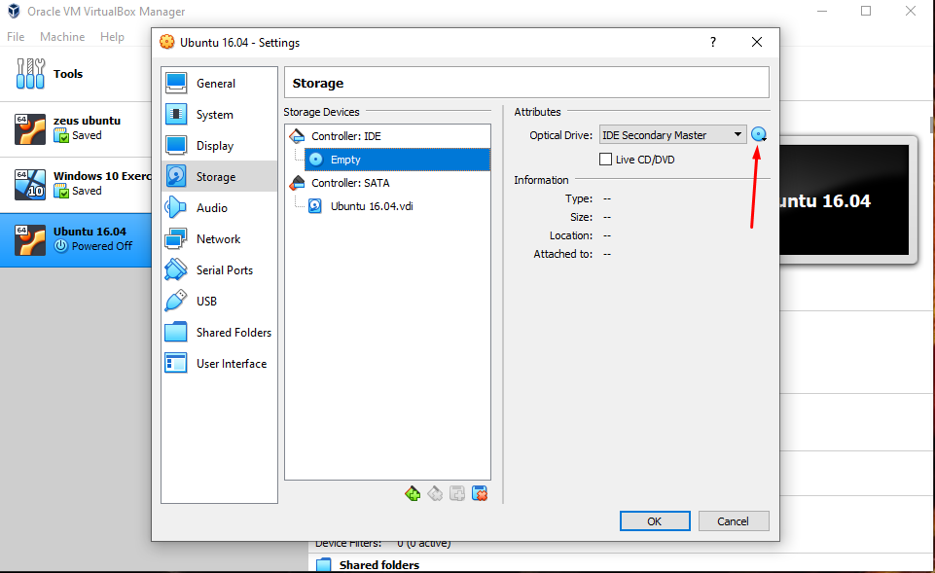

In this interface we will click “Install Ubuntu” and we will choose “Download updates while installing Ubuntu” and select “Something Else” for a better configuration.
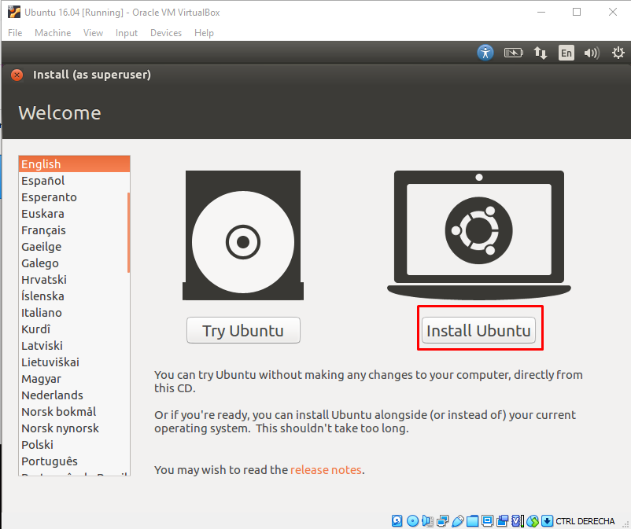
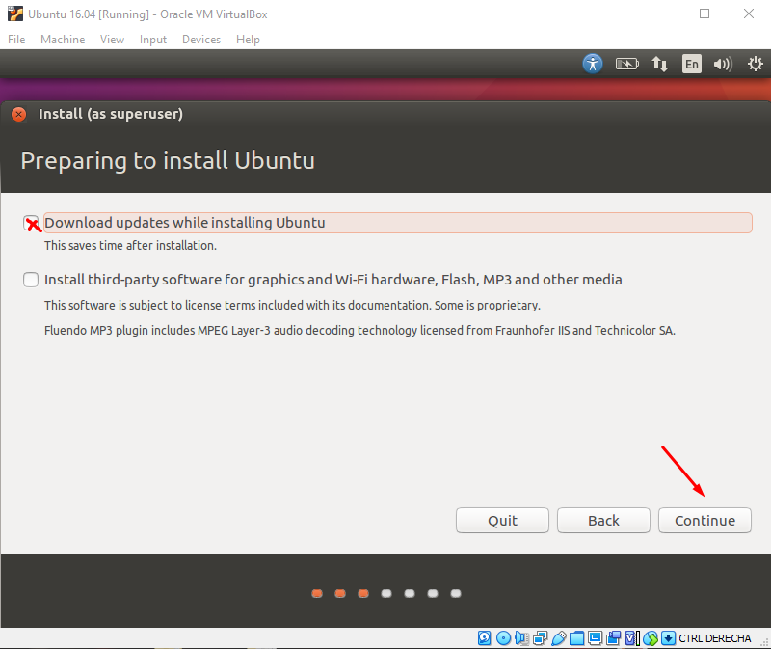
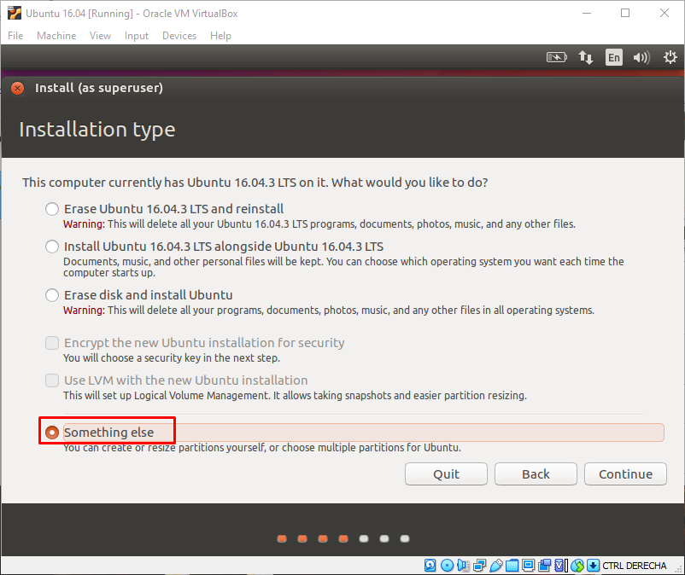

After selecting “Something Else” we will have a new interface in which we will be able to make partitions from our 30GB hard drive. We will click “New Partitions” and do the following:
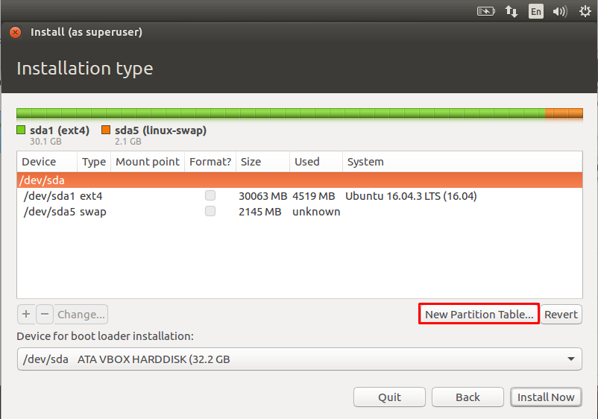

The first partition we will need must have this characteristics:
- 1GB (1024MB) of memory
- Its type will be “primary”
- Its location will be “beginning of this space”
- It will be used as “ext4 journaling file system”
- Its mount point must be “/boot”
**Warning: as this first configuration will not end until Ubuntu is fully installed, you may have problems writing some symbols because of the english layout. To write “/” you will need to press “-” on your keyboard.

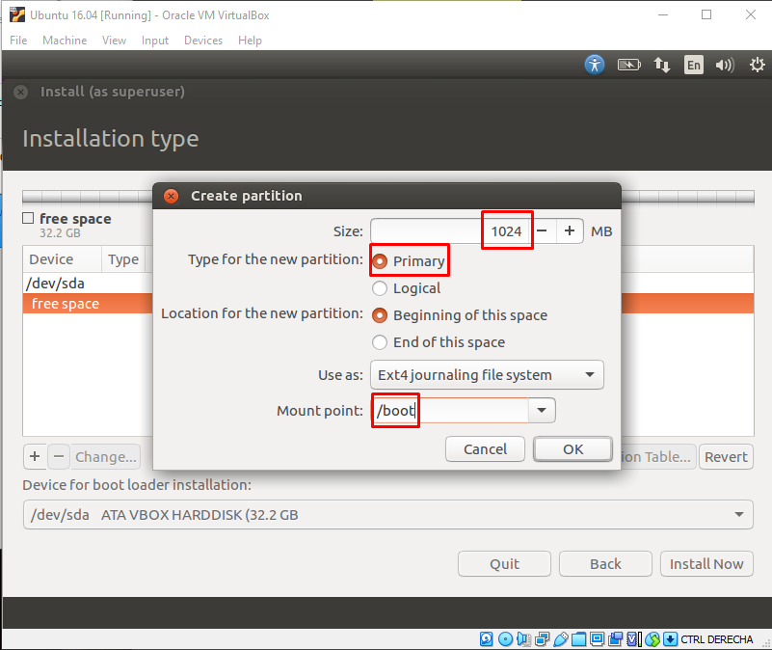

For the second partition we will need:
- 2GB (2048MB) of memory
- Its type will be “logical”
- Its location will be “beginning of this space”
- It won’t have a mount point, we will need to change its use to “swap area”

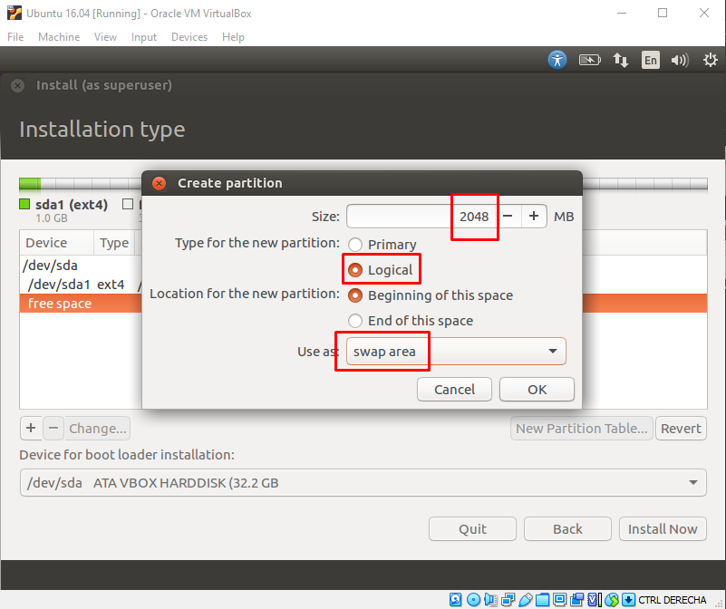

For the third partition:
- 15000MB of memory
- Its type will be “logical”
- Its location will be “beginning of this space”
- It will have its use as “Ext4 journaling file system”
- In the mount point we will have to write just “/”

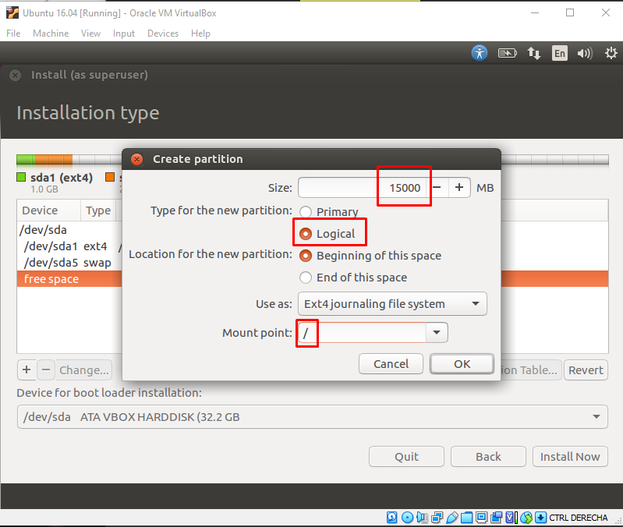

For the last partition:
- 14140MB of memory
- Its type will be “logical”
- Its location will be “beginning of this space”
- Its use will be “ext4 journaling file system”
- Its mount point must be “/home”

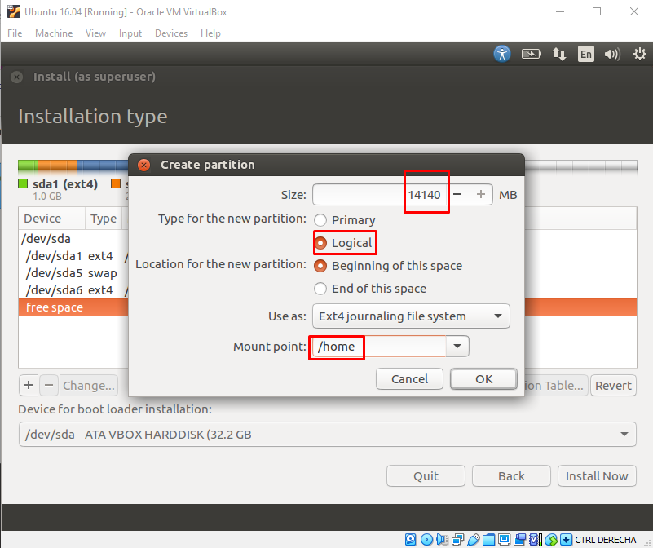

Now, we will click “Install now” and “Continue”.
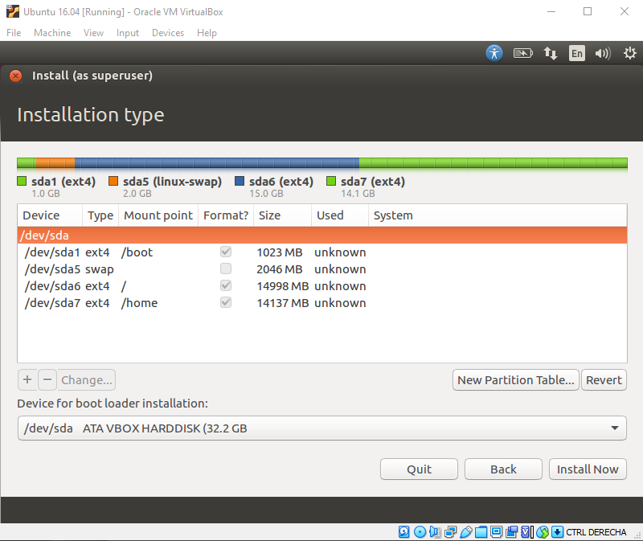
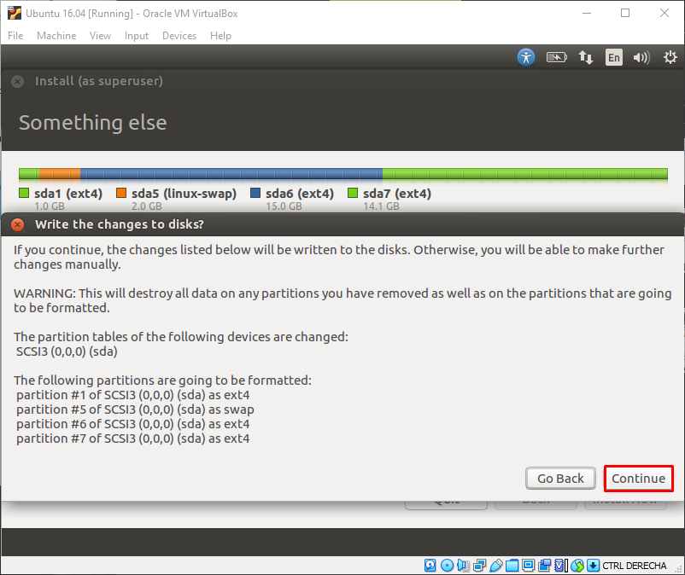

When this process finishes, we will have to do the final configurations:
we will need to select our location, our keyboard’s layout and configure our user and password.

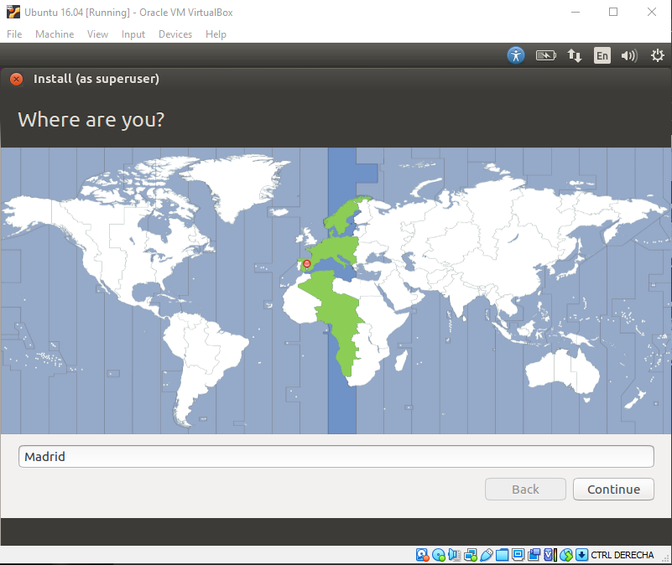
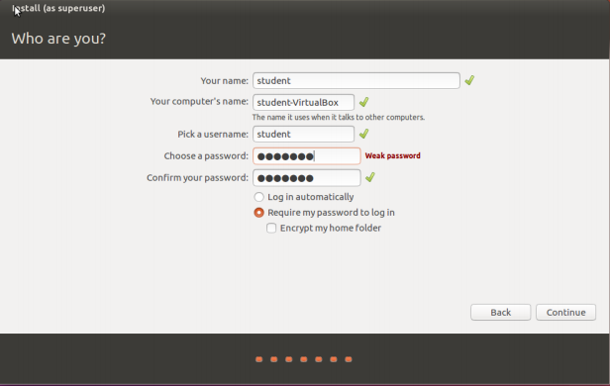
At this point, all the configurations will be done. The system will work itself and will ask you to restart the virtual machine.
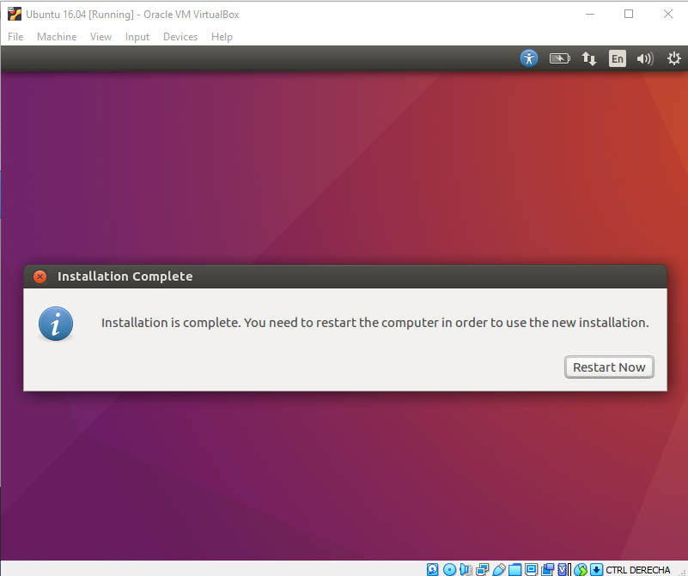

Finally, we need to do 2 more things:

The first one is to press “Devices” in the VirtualBox’s window and then click “Insert Guest Additions CD...”. This setting will create a more direct interaction between the virtual and the physical machines.
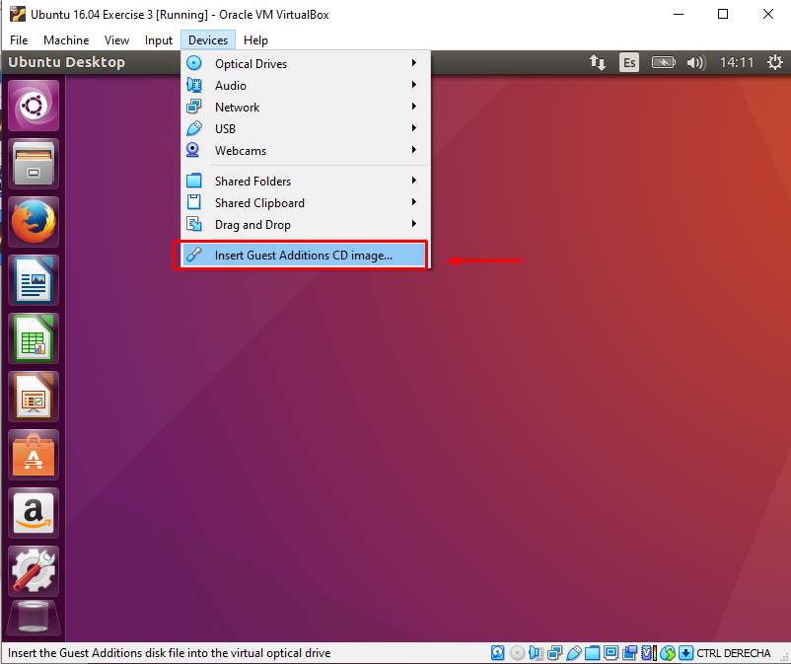

The second, and last one, is to open Ubuntu’s terminal (shortcut: Ctrl + Alt + T) and we will need to type “sudo adduser [username] vboxsf” and type our password to make our user able to access the shared folders.

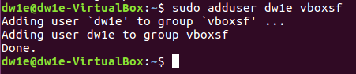

At this point, you will have Ubuntu ready for your use!

ALFREDO PUERTA GALLEGO DW1E

